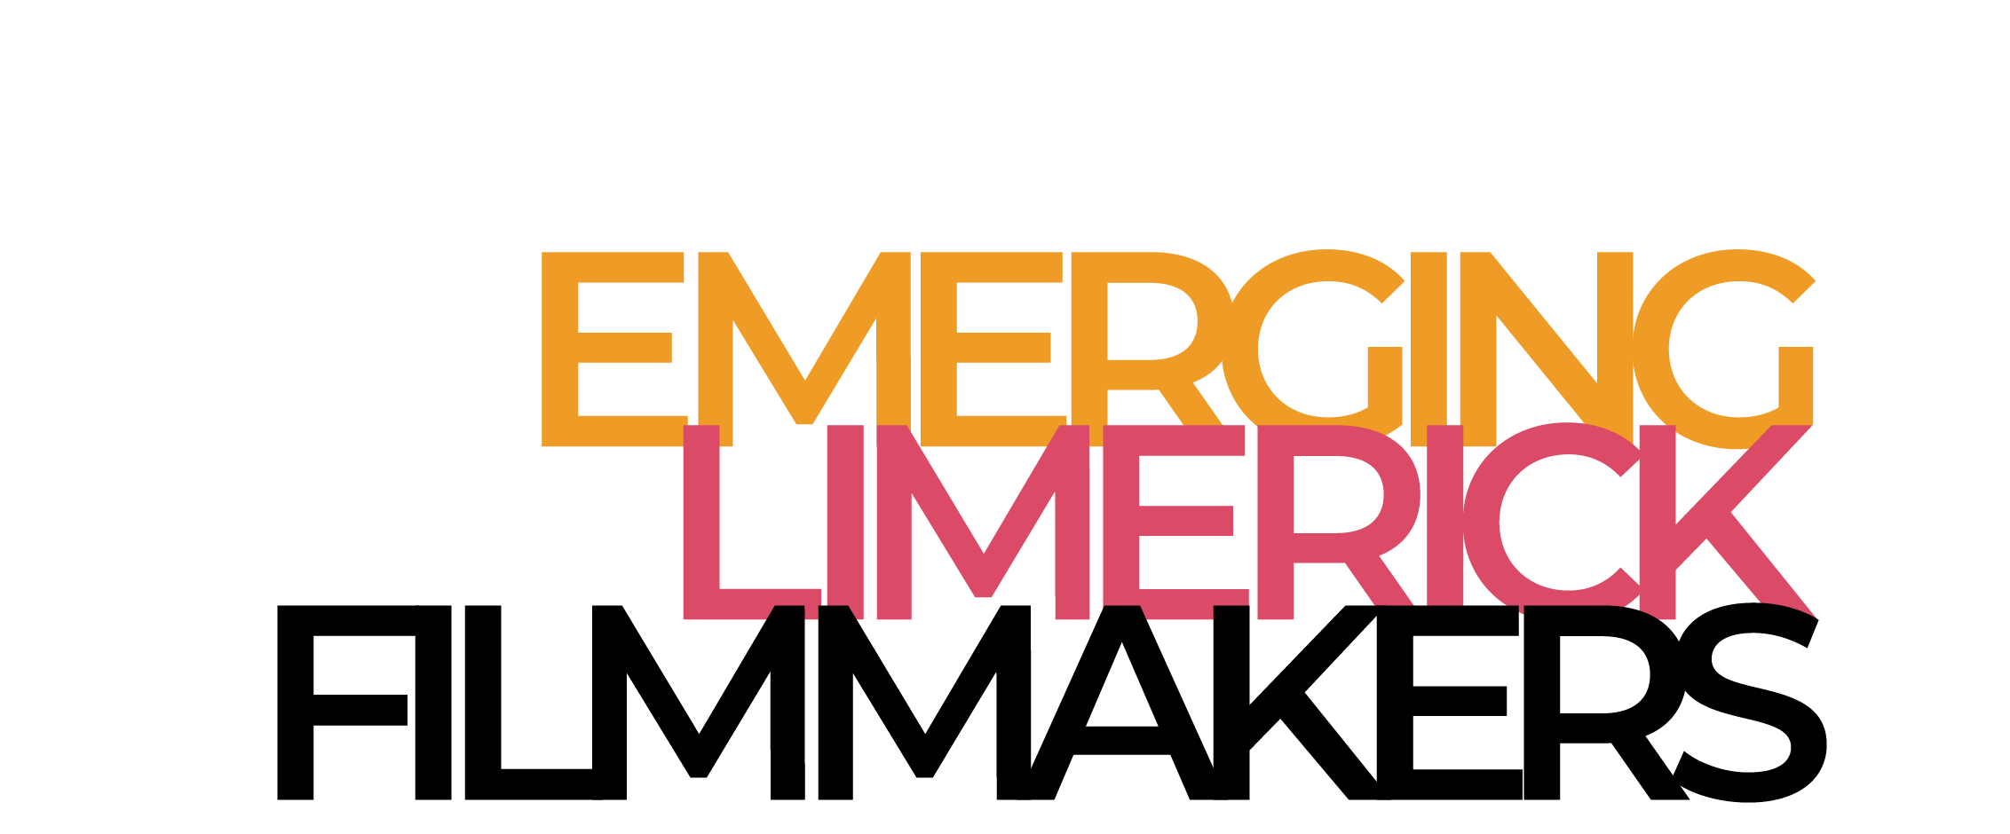

Emerging Limerick Filmmakers
Application Form 13-18 Age Group

Your information will not be used for any purpose other than as a means to contact you. We will handle all information with sensitivity and retain your privacy.

1. Personal Information
Name:

Surname:

Date of Birth:

Nationality:

2. Contact Information
Home Address:

Phone/Mobile:

Email:

Name of parent/guardian and email address/phone number
(If under 18)

Best way to reach you:
(Phone/email/post)

3. Why do you want to join our filmmaking collective?
Tell us in your own words what you hope to gain from and bring to the organisation. What sort of filmmaker are you, or do you hope to be?

4. What do you hope to achieve/expect from ELF?
For example: what aspects of filmmaking are you interested in - scriptwriting, directing, cinematography, editing, sound etc. What are you passionate about?

5. Anything Else?
Please use this section to share anything else that you feel will help demonstrate your desire to be a filmmaker. Do you have work to share? Any final comments? Tell us.

Email: emerginglimerickfilmmakers@gmail.com

APPLICATION FORM

The form must be emailed to the email address listed above by October 5th. Successful applicants will be called for an interview on the 9th of October, with replies being sent as soon as possible, with details included in a reply.

If you need to send a physical copy of the form, email ELF and we can provide an address.

It is expected that this will be a competitive call for applicants, so please, if you are not successful this time, keep trying, keep doing what you’re doing. Many great filmmakers didn’t succeed at their first try. ELF is fallible.

There are two bursary places available for those who need financial support. Please indicate if you hope to avail of this support, and please recognise that these supports are for participants who otherwise could not join the organisation. Membership fees go back into the production of short films.

The fee per year will be €100.

General guidance about interviews

Interviews will be informal, with a panel of young filmmakers asking questions about, well, film. We’re a young organisation, so we’re still working out how all this works.

Applicants will be informed of the outcome of their interview the following day.

